**SLEEP APNEA DETECTOR**



Submitted by:

**Aatif Husain**

**2K20/EC/03**

([aatifhusain_ec20b11_53@dtu.ac.in](mailto:aatifhusain_ec20b11_53@dtu.ac.in))

**Amarnath Yadav**

**2K20/EC/26**

(amarnathyadav_ec20b11_72@dtu.ac.in)

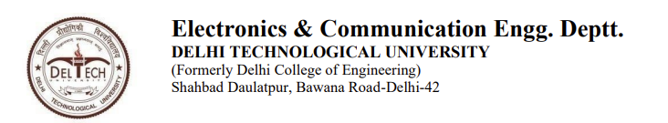

**CERTIFICATE**

I hereby certify that the Project titled "**SLEEP APNEA DETECTOR**" which is submitted by, Department of Electronics & Communication Engineering, Delhi Technological University, Delhi is a record of the project work carried out by the students under my supervision.

Mr. Ms Choudhry

**SUPERVISOR**



**CANDIDATE’S DECLARATION**

We, hereby, declare that the work embodied in this project entitled "**SLEEP APNEA DEATECTOR**" submitted to the Department of Electronics & Communication Engineering, Delhi Technological University, Delhi is an authentic record of our own bonafide work and is correct to the best of our knowledge and belief. This work has been undertaken taking care of engineering ethics.

Name of students:

Aatif Husain(2K20/EC/03)

Amarnath Yadav(2K20/EC/26)



**ACKNOWLEDGEMENT**

We express our sincere thanks to Prof. Yogesh Singh, Vice-Chancellor, Delhi Technological University, Delhi. We pay our deep sense of gratitude to Prof. N. S. Raghava (HOD) of ECE Department, Delhi Technological University, Delhi to encourage us to the highest peak and to provide us the opportunity to prepare the project. We feel to acknowledge our indebtedness and deep sense of gratitude to our guide Mr. Ms Choudhry whose valuable guidance and kind supervision given to us throughout the course which shaped the present work as its show. We are immensely obliged to our friends for their elevating inspiration, encouraging guidance and kind supervision in the completion of this project.

NAMES OF STDUENTS:

Aatif Husain(2K20/EC/03)

Amarnath Yadav(2K20/EC/26)

**TABLE OF CONTENTS**

1. Aim of the project
2. Abstract of the project
3. Introduction to sleep apnea
4. Implementation/approach
5. Code
6. Output
7. Conclusion of the project
8. Future scope
9. References

**AIM:**

To implement a sleep apnea detector.

**ABSTRACT:**

sleep apnea is a well-known sleep ailment. SA mostly occurs due to the shortage of oxygen for the human body, which causes several symptoms (i.e., low concentration, daytime sleepiness, and irritability). Discovering the existence of SA at an early stage can save lives and reduce the cost of treatment. The computer-aided diagnosis (CAD) system can quickly detect SA by examining the by analysingthe audio of the sleeping noise of a person in a frequency domain. In this we will use matlab to analyze the audio of non-apenatic person and apenatic person and we will use data from the given output to finally conclude that the person has sleep apnea or not.

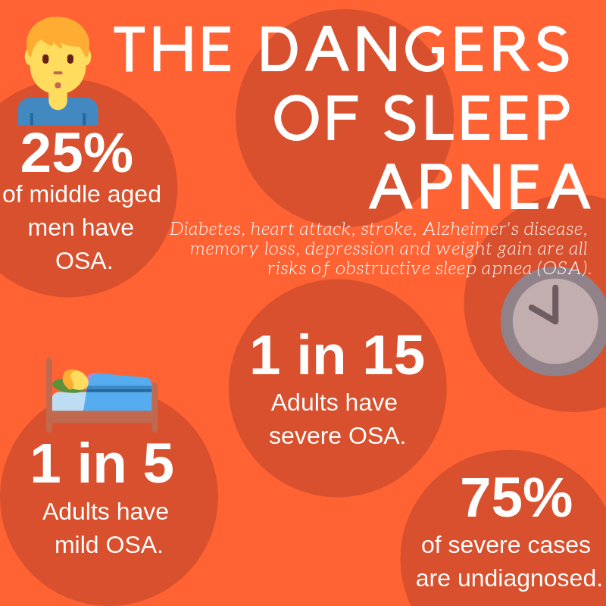

**INTRODUCTION**

Sleep apnea is a common disorder that causes your breathing to stop or get very shallow. Breathing pauses can last from a few seconds to minutes. They may occur 30 times or more an hour.

The most common type is obstructive sleep apnea. It causes your airway to collapse or become blocked during sleep. Normal breathing starts again with a snort or choking sound. People with sleep apnea often snore loudly. However, not everyone who [snores](https://medlineplus.gov/snoring.html) has sleep apnea.

You are more at risk for sleep apnea if you are overweight, male, or have a family history or small airways. Children with enlarged [tonsils](https://medlineplus.gov/tonsillitis.html) or [adenoids](https://medlineplus.gov/adenoids.html) may also get it.

Doctors diagnose sleep apnea based on medical and family histories, a physical exam, and sleep study results.

When your sleep is interrupted throughout the night, you can be drowsy during the day. People with sleep apnea are at higher risk for car crashes, work-related accidents, and other medical problems. If you have it, it is important to get treatment. Lifestyle changes, mouthpieces, surgery, and breathing devices can treat sleep apnea in many people.

**IMPLEMENTATION/APPROACH**

Using comparative analysis for an apneatic and a non-apneatic person, we try to find threshold values for a sleep of a normal signal and the sleep of an apneatic person. This approach is carried out on a population of 10 people so that the values can be verified and generalised for the population.

The dataset that we have is of 10 people in which 5 are apneatic and 5 are non-apneatic. The dataset in the form of **wav audio file** where all the files are of 1 minute and 20 seconds(approximately) and this is done so that the comparison becomes easier between various values and ranges.

The approach is simple, that is to observe the values and ranges of a normal person and to observe the values and ranges of an apneatic person and by these values, we are able to set some threshold value and if for any person the value exceeds the threshold value, we can say that the chances of apnea in him/her are higher.

Using MATLAB, we create two criteria to compare, that is we first convert the given audio input into its time domain and then calculate various statistical information like mean, standard deviation, maxima and minima, using them we make certain references like the time domain plot of a normal person would be more or less periodic where the peaks will have values close to each other.

On the other hand, for an apneatic person the graph would not be periodic and the nature of the peaks would be non-uniform/random and the maxima for a non-apneatic person would be much greater than that of a normal person.

After comparing in the time domain, we then carry out the observations in the frequency domain. Time domain shows us how a signal changes over time, frequency domain analysis show us how the signal’s energy is distributed over a range of frequencies. A signal can be converted between the time and frequency domains with a pair of mathematical operators called a transform. An example is the Fourier transform, which decomposes a function into the sum of a (potentially infinite) number of sine wave frequency components. The 'spectrum' of frequency components is the frequency domain representation of the signal. The inverse Fourier transform converts the frequency domain function back to a time function. The **fft** and **ifft**functions in MATLAB allow you to compute the Discrete Fourier transform (DFT) of a signal and the inverse of this transform respectively.

In the frequency domain, we try to observe and compare the difference in amplitude, the frequency ranges and the frequency distribution over some values.

**CODE**

Time domain analysis: -

[x,fs]=audioread("name_of_the_audio_file.wav")

//this line basically converts the audio input in wav format into a set of datapoints in a matrix, where each element contains the amplitude at certain point of time and this matrix is stored in x whereas the fs calculates the sampling frequency and for this project, sampling frequency for every data is 4800 Hz.

x=x(:,1);

//x here becomes the length of one entire column

N=length(x);

t=(0:N-1)/fs;

//by dividing the length of the entire column with the sampling frequency we obtain the time of the audio input

%plot time domain signal

plot(t,x)

grid on

xlabel('time(s)')

ylabel('ampl')

title('signal in time domain')

%stats information

maxValue=max(x)

minValue=min(x)

meanValue=mean(x)

stdValue=std(x)

//this calculates various statistical information like maxima, minima, mean and standard deviation.

Frequency domain analysis: -

[y,fs]=audioread("sample_audio.wav");

%frequency domain

nfft=length(y);

//this basically tells us the length of the signal we want to calculate the fourier transform of

f=linspace(0,fs,nfft);

Y=abs(fft(y,nfft));

figure;

plot(f(1:nfft/2),Y(1:nfft/2));

title('freq domain')

xlabel('freq')

ylabel('abs')

**OUTPUT**

Time domain comparison: -

1. Apneatic person

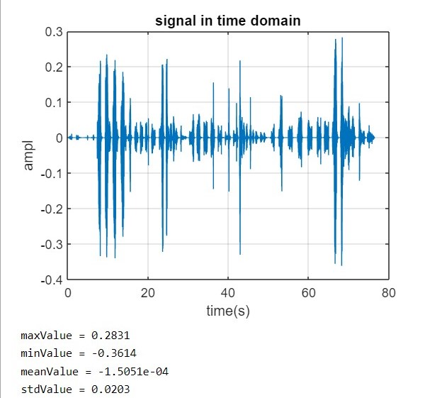

1. Non apneatic person

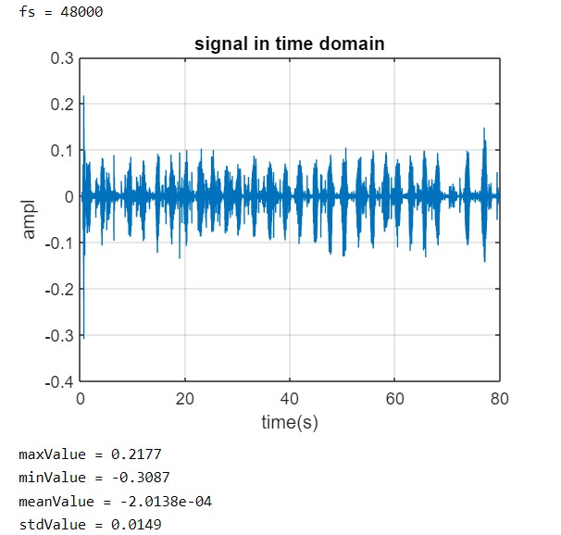

Frequency domain comparison: -

1. Apneatic person

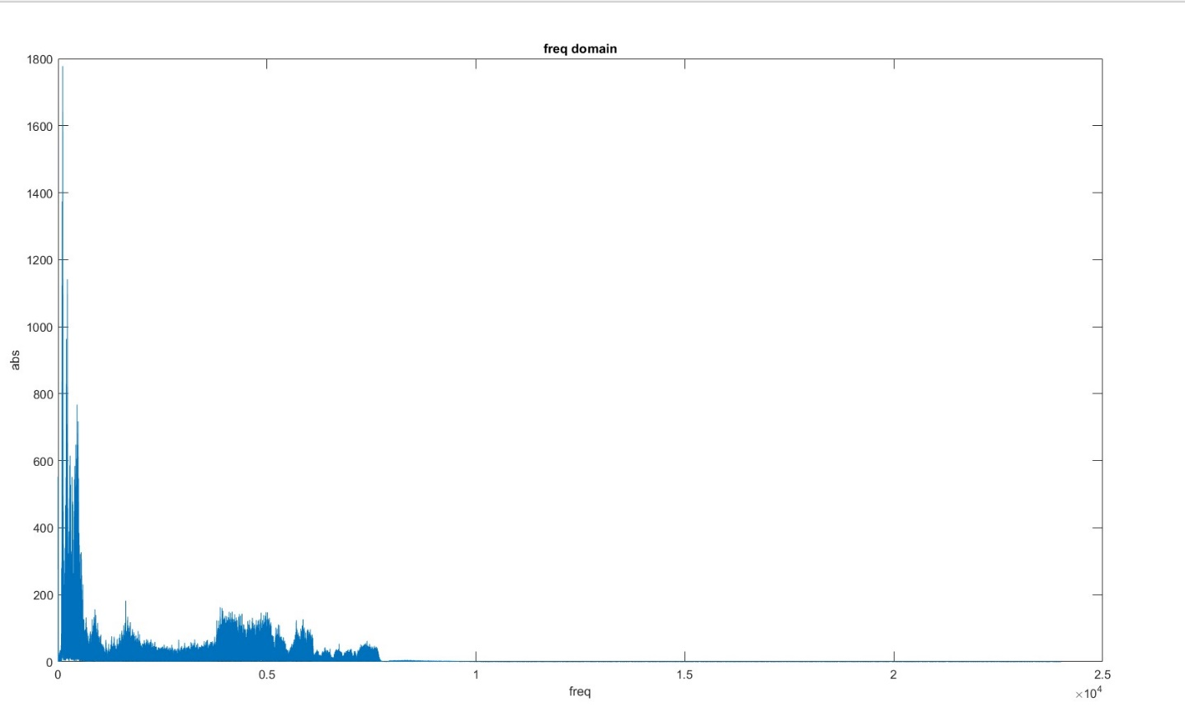

1. Non apneatic person

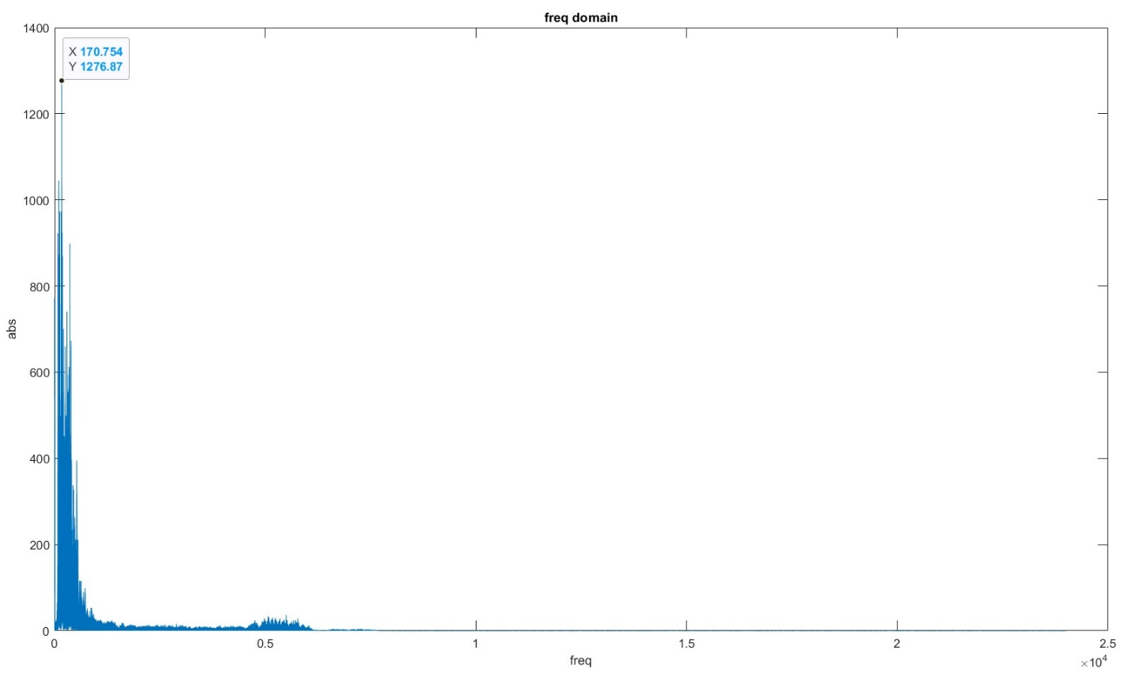

**CONCLUSION**

1. In the time domain, we were clearly able to see the nature of the waveform of an apneatic person and that of a non-apneatic waveform.
2. Standard deviation is a measure of how dispersed the data is in relation with the mean, in all of the 10 datasets the standard deviation of an apneatic person was always found to be more than any of the standard deviation of the normal person. Maxima and minima also differ greatly.
3. Frequency domain shows us the difference in the amplitude that is the difference in the energies at various frequencies.

The most prominent difference was revealed in the frequency range of 400 to 1000 Hz, in this range, a fair share of energy is distributed for an apneatic person whereas for a non-apneatic person the energy is largely distributed till 500 Hz and this is verified as the snoring is considered to be normal when it is below 500 Hz.

Thus we conclude that when there is a distribution of energy above the frequency range of 500 Hz, we can say that the chances of apnea in that particular person is higher and the person is potentially at risk.

**Future Scope**

* In Future we can use the current model and modify using Machine learning and Neural Network to directly Identify the Sleep Apnea.
* We can make our model more perfect and accurate using more Dataset in the future
* We can also modify our Model to detect other breathing related disease like Asthma ,Chronic bronchitis and Cystic fibrosis.
* We can also use the Given model to detect small Problems related to Heart.

**Refrences**

* <https://en.wikipedia.org/wiki/Sleep_apnea>
* <https://my.clevelandclinic.org/health/diseases/8718-sleep-apnea>
* <https://www.mayoclinic.org/diseases-conditions/obstructive-sleep-apnea/symptoms-causes/syc-20352090>
* <https://www.researchgate.net/publication/305741683_The_Frequency_and_Energy_of_Snoring_Sounds_Are_Associated_with_Common_Carotid_Artery_Intima-Media_Thickness_in_Obstructive_Sleep_Apnea_Patients>
* <https://in.mathworks.com/help/matlab/ref/fft.html>
* <https://in.mathworks.com/matlabcentral/answers/547116-how-to-convert-time-domain-curve-to-frequency-domain>